**Experiment 3.4**

**Aim:** To write python program to Implement different types of exceptions.

**Solution:**

Try, Except and Finally

try:

f = open('somefile.txt', 'r')

print(f.read())

f.close()

except IOError:

print('file not found')

try:

num1, num2 = eval(input("Enter two numbers, separated by a comma

: "))

result = num1 / num2

print("Result is", result)

except ZeroDivisionError:

print("Division by zero is error !!")

except SyntaxError:

print("Comma is missing. Enter numbers separated by comma like

this 1, 2")

except:

print("Wrong input")

else:

print("No exceptions")

finally:

print("This will execute no matter what")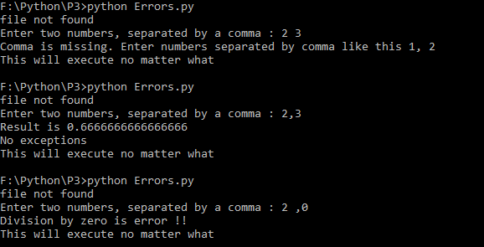

Raising exceptions

def enterage(age):

if age <= 0:

raise ValueError("Only positive integers are allowed")

if age % 2 == 0:

print("age is even")

else:

print("age is odd")

try:

num = int(input("Enter your age: "))

enterage(num)

except ValueError:

print("Only positive integers are allowed")

except:

print("something is wrong")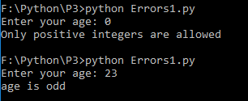

Assertions

def avg(marks):

assert len(marks) != 0,"List is empty."

return sum(marks)/len(marks)

try:

mark2 = [55,88,78,90,79]

print("Average of mark2:",avg(mark2))

except AssertionError as v:

print(v)

try:

mark1 = []

print("Average of mark1:",avg(mark1))

except AssertionError as v:

print(v)